

CSA0501-DATABASE MANAGEMENT SYSTEMS

LAB EXPERIMENTS DATE: 12/07/2026

EXPERIMENT4 – DML Commands (UPDATE,DELETE)

AIM:
To perform Data Manipulation Language (DML) commands such as UPDATE and DELETE in the dairy Management System database.

PROCEDURE:
- Open MySQL and create the dairy Management System database.
- Create the dairy table with appropriate attributes.
- Use the UPDATE command to add dairy records into the table.
- Execute the DELETE command to display all dairy records.
- Verify that the inserted data is displayed correctly.
- Observe the output and ensure the DML commands are executed successfully.

PROGRAM:

1. CREATE TABLE:

CREATE TABLE dairy(

name VARCHAR(30),

liters int(40),

amount int(100),

account_number BIGINT(20),

phone_number BIGINT(13),

bank_name VARCHAR(30)

);

OUTPUT:

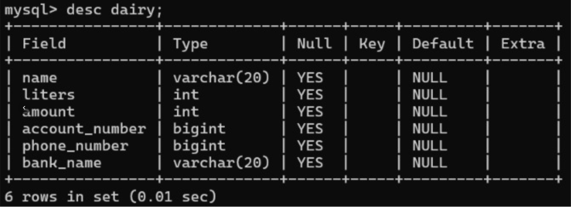

2. UPDATE COMMAND:

UPDATE INTO dairy
SET amount=500
WHERE name=’nagu’;

OUTPUT:

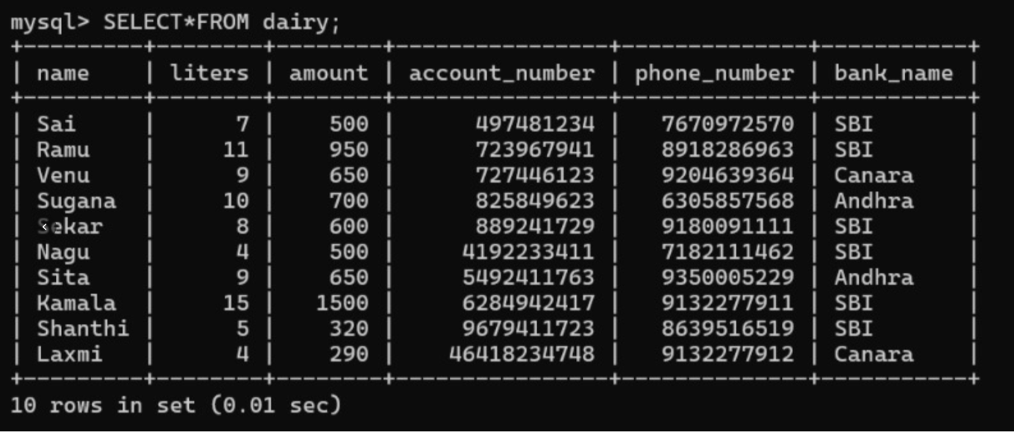

3. DELETE COMMAND:
SELECT * FROM dairy;

DELETE INTO dairy
DELETE row WHERE name ‘venu’;

OUTPUT:
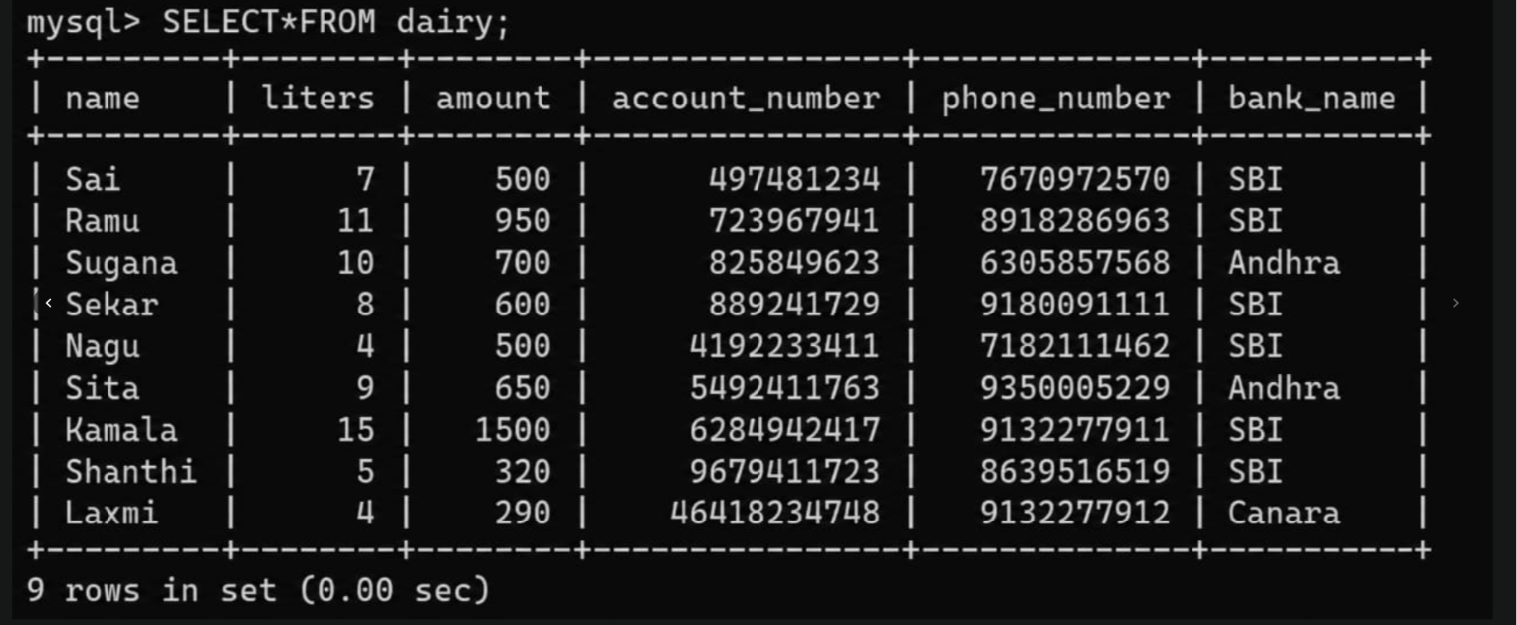

4. UPDATE COMMAND:

UPDATE INTO dairy
SET liters= 6
WHERE name=’laxmi ‘;

OUTPUT:
.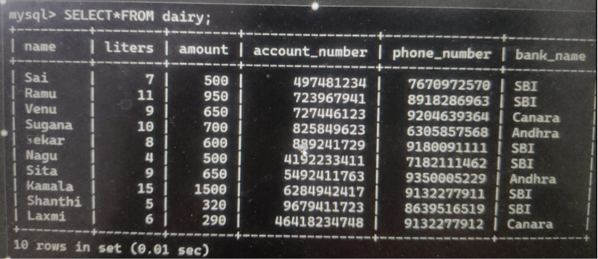

5.DELETE COMMAND
SELECT*FROM dairy
DELETE INTO dairy
DELETE coloumn WHERE ‘amount’;
OUTPUT:

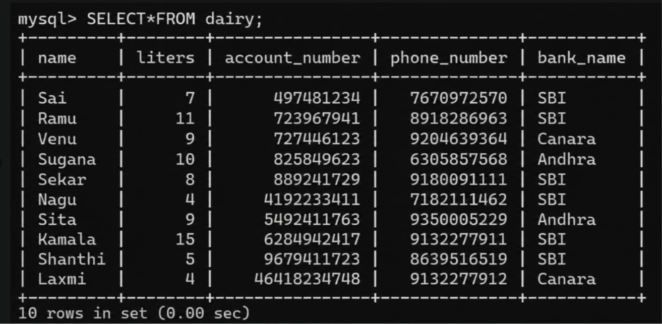
RESULT: Data Manipulation Language (DML) Commands such as UPDATE, DELETE are performed

